Gaurav Singh

Foundations of Leadership | C-U 002

17 November 2022

**Initial Vision**

### 

|  |
| --- |
| By my signature below, I certify that I have not received improper help nor given it to others in writing this assignment, nor have I used any method that would give me an unfair advantage over others in the class. This assignment represents my own work only, and I had no assistance from another person or any other source unless it is referenced at the bottom of each appropriate page.  Gaurav Singh  Date: 18-11-2022 |

**Life journey till now**

While writing about significant people and events in my life, my parents will be the first one to come in the list. I have seen them doing everything that they can afford for me. Let me introduce you to my father who is in the Border Security Force (B.S.F). Yes, as you all know military guys only get a few months holiday, so he can't meet very frequently with me but still he cares a lot about me, and I have seen him managing everything from his own work to everybody’s needs and choices in my family and me and my sister’s education expenses from a limited amount of money. I wish to get all these managerial skills from my father. My mother is a housewife, but she is the one who is holding all of us together, many times it happens that my father don’t allow me to go somewhere or to do something, but it is my mother who then talk to both of us in a way that after her talk both of us have to agree on the same thing. I am a true fan of her convincing power, tolerance power and loving nature.

When I was in 9th standard then I joined a new coaching class where I met my life’s first mentor “Dr. Prem Jyoti Singh Rana”. Yes, his name is very long but so is our journey together. At that time, he was doing his M.Sc. in Chemistry, but he taught us all the Science subjects and he is very good at all of them. In the first two meetings with him, I felt a different connection with him and for him also, it is the same. Apart from my family he was the first person who always said to me that I have the potential to achieve anything in life, he motivated and supported me at every turn of my life. Right now, he is doing his Post doctorate from University of North Carolina and still we are in contact with each other. But now I have taken this pledge that now I will only call him after the completion of TLP, when I have something good to show to him as my achievement, so that he could feel proud of me. He is a very hard-working man who has achieved a lot in his life but still his ground to earth and positive nature always inspires me to be like him.

So, till my high school I was in a school which was close to my house and for seven consecutive years I was the topper of my school. At that time, I got a sense of overconfidence in me but soon that overconfidence was going to be broken. I gave the admission test for the 11th standard for the best school in my city. Luckily, I got the admission, but after going there and sitting with such brilliant minds who know a lot about many things and are good at several things at a time. I realized that I was nothing in front of those students, for a few days I felt demotivated and helpless. But a good thing that happened to me at that time was that I learned to believe in myself, and I remember saying this line to myself every day that “You are different from others, You can do this Gaurav”. I started giving all my efforts in my studies. In the end I got a fruitful result, I was in the list of top 5 students of my class in senior secondary. That time I realized that “will power” and “consistency” can make a person invincible.

After completing my senior secondary education, as most of the STEM students in India do, I also followed the same path and went to Kota, Rajasthan to prepare for the JEE exam (exam to get into IITs and NITs). Just before going there, I came into the first relationship of my life and due to many things, that didn’t go well. So, after six months while I was in Kota, we ended that, and my studies were badly affected by this incident. Still sometimes I wonder what would be a better option for me at that time. Should I have controlled myself for one year and after that should have started talking to her? or Should I have tried to manage all the things properly? That is in the past, but the experiences in my life after this phase are really amazing. The few things that I want to take from my Kota experience is that before making any decision one should think about the consequences and in order to trust someone, give some time to understand that person better and also never bring ego in any relationship. In terms of study, I learnt a very important lesson that to succeed in life you should ‘work smart’ more than you ‘work hard’.

After Kota I went to college where my real amazing and adventurous life started. Lot of fun, lot of friends and a lot of memories will remain with me forever from my college life. But there are two things which my college life gave me that I will cherish for my lifetime. First one is that I make my friendship group, which has six people (including me) who are very close to my heart and the name of our group is **“YAARI”** which in English means pure friendship. And the best part is that five of us belong to the same city so there is no chance of not having meetings frequently. In my group each of us is different but still few things which we have in common are the support, love, and sense of encouragement for each other. There were many phases when we fought with each other, when some among us got placed in good companies and some were still in process but still, we all faced all those things together and I think that made me realize that with love and true support from the right people, you can conquer anything in this world. And yes, the second thing is that I got to meet someone very special about whom I will not disclose anything because we both agreed on this thing that we have to keep this private till it becomes permanent. Also, I personally think that some things you should keep private otherwise the magic in that thing goes off. 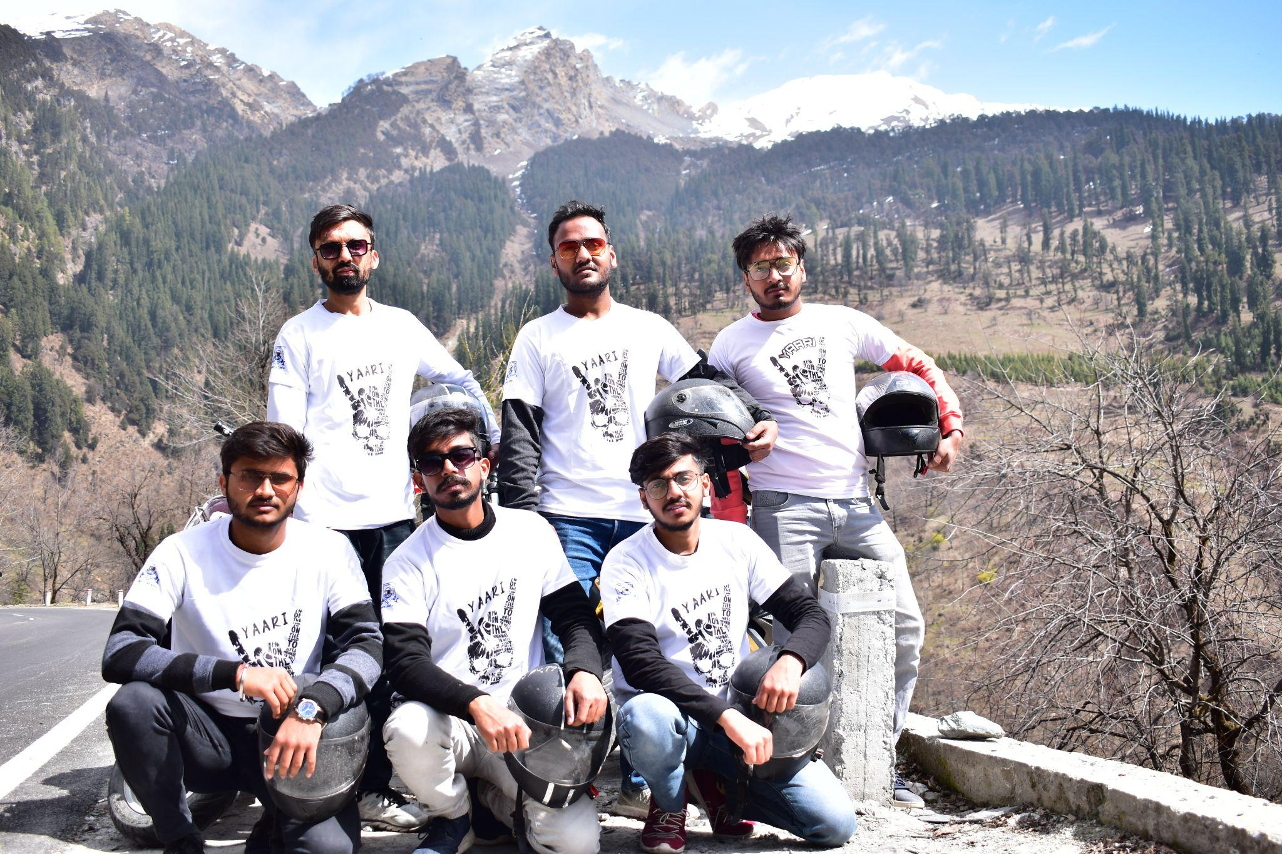

In the third year of my bachelors, I got placed in a good firm and I started working there, since I was not sure if that is the thing which I want to do for the rest of my life so to explore other opportunities, I was also preparing for post-graduation admission exams. But after a few months, I realized that the work which I was doing there was not my cup of tea but still I can’t leave that job directly without getting some other option, so I tried managing both things, my job and preparation for admission in Masters. But I was not able to perform well in either. I didn’t get my dream college but then I didn’t want to wait again for a year, so I searched for alternatives and Plaksha TLP gave me a ray of hope. After this incident I asked myself a few questions, what would be a better option for me, to just prepare for the exam without taking the job or to prepare for it once again with the job and give the exam next year. But I think the decision which I have taken now to come here at Plaksha is perfectly right and I am loving the experience, so why to think about what could have been done in the past? Let's just explore what we have now. Also, quite a good learning of mine from my college life is that don’t try to do everything, do few things but do them really well.

**My strengths**

* **Zest**

I am convinced that Zest is my superpower according to the VIA characteristic test. I can feel this inside me every day except for a few days when I feel down. Whenever I do something for someone either I don’t do it or do it wholeheartedly. It is in my genes from the very start of my life, whenever I get low grades in any subject or even if I fail in something, I used to feel down for some time but after that a very different kind of energy comes into me and again, I start working with more power.

* **Hope / Futuristic**

I think hope is indirectly related to zest. As whenever I feel down, it is the hope which makes me feel uplifted again. Thinking about my planned future most of the time and hoping I will achieve all of those things is something that drives me to work harder.

The kind of family I grew up in, I always have small dreams as small as having my own car in which I want to take my parents with me to a restaurant and we can enjoy food together. So, thinking about the future drives me towards my dreams and ‘hope’ gives me power to take needful steps to achieve my dreams.

* **Positivity / Positive Aura**

In my journey till now I made a lot of friends wherever I went, and I got this feedback from a lot of my friends that I have that positive aura that when they are with me they feel more positive and open. Positivity is something that I wanted to stay in me forever.

**Areas of improvement**

* **Perseverance**

My whole life after school days, I am always concerned with not being consistent with doing something (particularly studies) in my life. It’s like learning new things is very interesting for me but I can’t keep my perseverance to finish what I started. In school days it was not the case maybe because at that time we had limited things to do in a limited time, but now it is too hard to manage everything in a good way from start to end and that’s why I usually pick up another thing without completing the previous one. And I am stuck with these questions that if I do limited stuff how will I stand out in the crowd? and if I do a lot of stuff then how should I manage all of them well and finish them in limited time?

* **Fear of missing out**

Whenever someone is doing something related to studies in front of me and I am not doing something at that time then I feel anxiety. Even if I am sleeping and my roommate is studying, I feel so much anxiety that I can’t even sleep properly. Again, in school time I barely faced this emotion as at that time I didn't even think about all these things and even if someone was doing better than me then I took it as a competition but now I feel like how will I be able to compete with such talented minds. But I am trying to control this thing and make myself understand that everyone's work style and capabilities are unique and different.

**Type of leader I want to become**

I think a leader who is full of energy and positivity, this kind of leader I can become if I polish my strengths but with this I want to become a leader who takes responsibility and get the work done in the allotted time, a leader who manages everything really well, whether it is about handling his team members or handling a lot of different work, this kind of leader I want to become. If someone is working in my team under my leadership then he/she should be comfortable in sharing anything with me, they should respect me and also consider me as a friend at the same time and whenever they are working, they should feel like they are enjoying the work. If under my leadership I can create such an environment for team members, then I can call myself a true leader.

I want to become a leader who doesn't care much about the title but cares about the impact he/she can give to others, about how to influence team members to do better or how to influence them to fulfill the goal. Also, a leader should give an inspiration to other team members that anyone can be a leader, an inspiration to never give up on any certain goal, an inspiration that everyone will remember. I don’t want to become a leader who commands the team, but I want to be someone who does the work together with the team and acts as a motivator of the team and should stand up for the team.

I actually don’t want to take this title of a leader; I love working with people treating them as my good friends and I think only then the best output can come. Associating a title with you always bring some power which one should use wisely so whenever I will be having this opportunity to work as a team lead, first I will make sure that the whole team environment is friendly and will not make myself and them feel that I am the boss, It’s just like they should work freely and sincerely with having this thing in their mind that this is their team and they all are doing this together. I also accept that sometimes there is a need to be strict about certain things but at the end of the day getting the work done properly is what matters, so if they respect me and enjoy working in that environment then they themselves will do the work on time.